Virtual Plants Lab Activity
Background

Relationships among plants (Figure 1)
This phylogenetic tree shows the relationship among plants. Following the branching pattern from left to right shows the sequence of evolution of the various groups. The closest relative of all plants is a group of green algae called Charophytes. From these, there evolved the oldest land plants: the mosses. Later, the first vascular plants branched out: the ferns. Then came the plants with naked seeds, and most recently, the coated seed, flowering plants.

Nonvascular plants
The most familiar of these plants are the mosses. As the name nonvascular implies, these plants don't have tissues specialized for carrying water and nutrients up and down the body. They also don't have true roots and leaves. This means they cannot grow very tall, and must absorb nutrients and water through the "rhyzoids". In mosses, the gametophyte (n) stage is dominant, and the sporophyte (2n) stage is dependent, that is it grows out of the gametophyte. In other words, when you see a moss, what you observe is the gametophyte! This is in sharp contrast to flowering plants, where the visible plant is the 2n sporophyte, and the gametophytes are microscopic.

Vascular plants
We will be mainly focusing on the vascular plants in today’s lab. These are plants with a water-conducting system of tubes called the vascular system. More specifically, we will be looking at one of the two groups of the seeded vascular plants, the angiosperms, or flowering plants. Flowering plants produce flowers, which are shoots specialized for sexual reproduction. A Fruit is the mature, fertilized ovary of a flower. Fruits form from the outer parts of the ovary, and are an adaptation for the dispersal of seeds. A seed is a dormant embryo packaged with a food supply. When the embryo begins to grow into a plant it is said to be germinating.

The body of a vascular plant is composed of the root system and shoot system (below and above ground, respectively). The tips of the stem and root are the growing part of the plant; they are composed of dividing cells called primary meristems. These dividing regions are responsible for the production of the primary plant tissues and parts, and for growth in height.
Many plants also grow in diameter. This growth is called secondary growth, and is produced by the lateral meristems. Woody plants and most dicots have lateral meristems called cambia (singular: cambium) which produces the bark and new xylem and phloem. In a young dicot stem cross section, the cambium is a layer of dividing cells in between the xylem (on the inside) and phloem (on the outside). The annual cycles of growth in a woody plant, visible as tree rings in a cross section of the stem, are produced by cambia.

The following are additional important anatomical terms pertaining to plants that you will find in the Figures from the slides:

Epidermis – dermal tissue that forms the outer part of the stem and leaves. It is waxy and impermeable to minimize water loss through evaporation.
Parenchyma – storage cells in the stem and leaves; store sugars from photosynthesis
Vascular bundles – conducting tissue made up of phloem cells that carry sugar and xylem cells that carry water
Cuticle – waxy layer that protects the leaf from water loss
Mesophyll – middle leaf layer composed of parenchymal cells specialized for photosynthesis
Veins – vascular tissue made up of phloem and xylem
Stomata – openings along the epidemis that allow for gas exchange.
Guard cells – surround the stomata and act to open and close the openings.
Cotyledons - embryonic leaflets found in the embryo

Stem Anatomy (Figure 4)
The stem is the above-ground part that grows. The growing points of a stem are at the tip and on the sides, and consist of special dividing groups of cells called meristems. Vascular tissue in the stem is often located in bundles called vascular bundles. These bundles may occur scattered throughout the stem as in the monocots or they may be organized in a circular pattern around ground tissue (aka the pith) as in most dicots.

Root anatomy
Roots can be fibrous or taproots. They have meristems on their tips so they can grow in length, Fibrous roots are found in monocots and consist of a bunch of thin roots radiating out from a common starting point. Taproots are found in dicots, and consist of a large, central main root from which thin rootlets branch out. In most roots there is no ground tissue, but some taproots are adapted to serve as storage organs for the plant. These roots can accumulate starch during the growing season to fuel the growth of the plant in the following spring.

Leaf Anatomy (Figure 5)
The leaf is an organ originating from the apical meristem and primary meristems. The leaf vascular tissue is contained in vascular bundles as in the stem. The xylem of the leaf vascular bundle is located on top and the phloem underneath. In the dicot leaf, the middle layer of a leafis composed of two types of cells:
1. palisade mesophyll - tightly packed columnar cells, full of chloroplasts just beneath the upper epidermis.
2. spongy mesophyll - loose tissue with many intercellular spaces. It is usually found just underneath the palisade layer.
The leaf epidermis contains several structures called stomata through which gas exchange takes place. Stomata are more abundant on the lower leaf epidermis. Remember, there is no meristem in leaves because leaves do not grow new leaves! Guard cells are specialized epidermal cells that open or close the stomata to regulate water loss. When plenty of water is available, guard cells are swollen and the stoma is open to allow CO₂ in and O₂ out. When the plant is dry, the cells contract and close the stoma to minimize further water loss that could kill the plant.

Plant domestication (Video)
The plants we eat are in most cases not found in nature. They are varieties that we have selected through breeding, sometimes millennia ago. For many domesticated varieties the origin is clear, but for corn (aka maize) it's been somewhat of a mistery. Watch the following video and answer the questions below

https://www.biointeractive.org/classroom-resources/popped-secret-mysterious-origin-corn

Plants Lab Questions

From Figure 1, Which plants are the closest relatives of the flowering plants? How can you tell?

What is meant by "alternation of generations"?

What are the main differences between a monocot and a dicot stem?

Briefly define "cotyledon". How many do you expect to find in a monocot plant? How many would there be in an apical meristem?

You are looking at a flower made up of 12 petals. What is this plant likely to be? Explain your answer.

What is a seed?

Label the structures indicated by letters in the cross section below
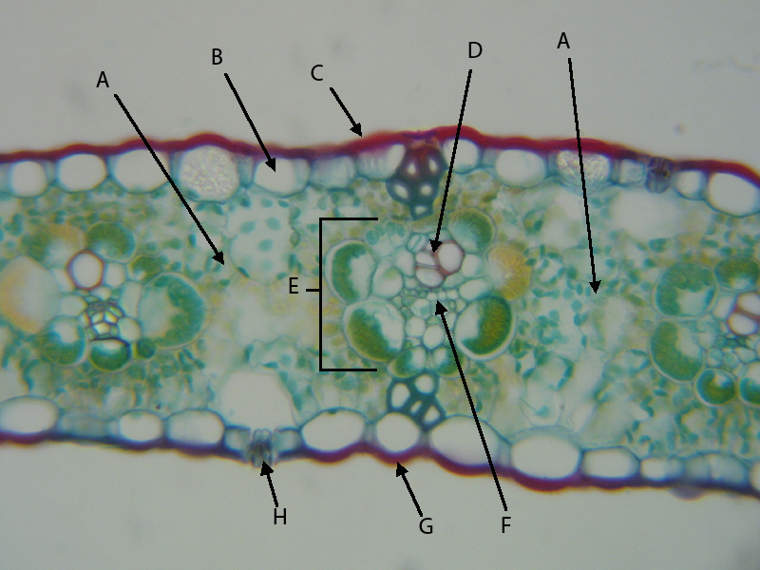
A:
B:
C:
E:
H:

What is the function of the guard cells, and where would you find them in the figure above?

What is the function of the epidermis?

5. In the figure below, label the roots as fibrous or taproot:

A | B | C | D

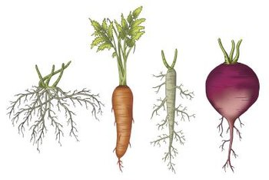

Which of these plants is a monocot?

Are any of these roots adapted for storage?

Observe the cross-section of this stem: would you classify it as a monocot or dicot? Explain your answer.

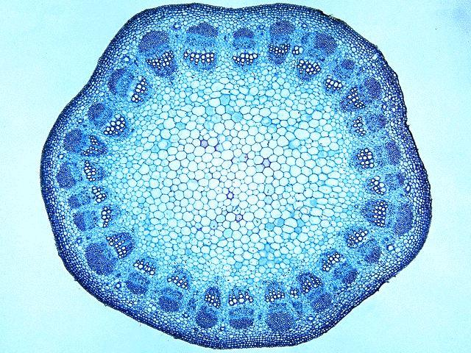
A
B

C

Label the indicated structures: A: B: C:

Does this stem have a cambium? if so, where is it located?

Questions for the video "popped secret: the misterious origin of corn"

What is a crop? Where do crops come from?
Who first proposed that theosynthe is the ancestor of corn? What was his evidence?

What experiments were devised to demonstrate that theosynthe is the ancestor of corn?

How was DNA sequence data used to figure out where and when theosynthe was domesticated to corn?

How did archeologists contribute to the investigation? What did they find, and did it agree or disagree with the DNA-based evidence?

What two important genes changed in theosynthe to cause it to become more like corn? How was this demonstrated?

If theosynthe has such a hard case around the kernels that it cannot be eaten as such, how was theosynthe hypothesized to have been consumed before domestication?

